# Scenario 1

Scenario Description: This scenario is intended to demonstrate that the employee census stored procedure works

Scenario Screen Captures of Output:

# Scenario 2

Scenario Description: This scenario is intended to demonstrate that the employee detail stored procedure works

Scenario Screen Capture of Output:



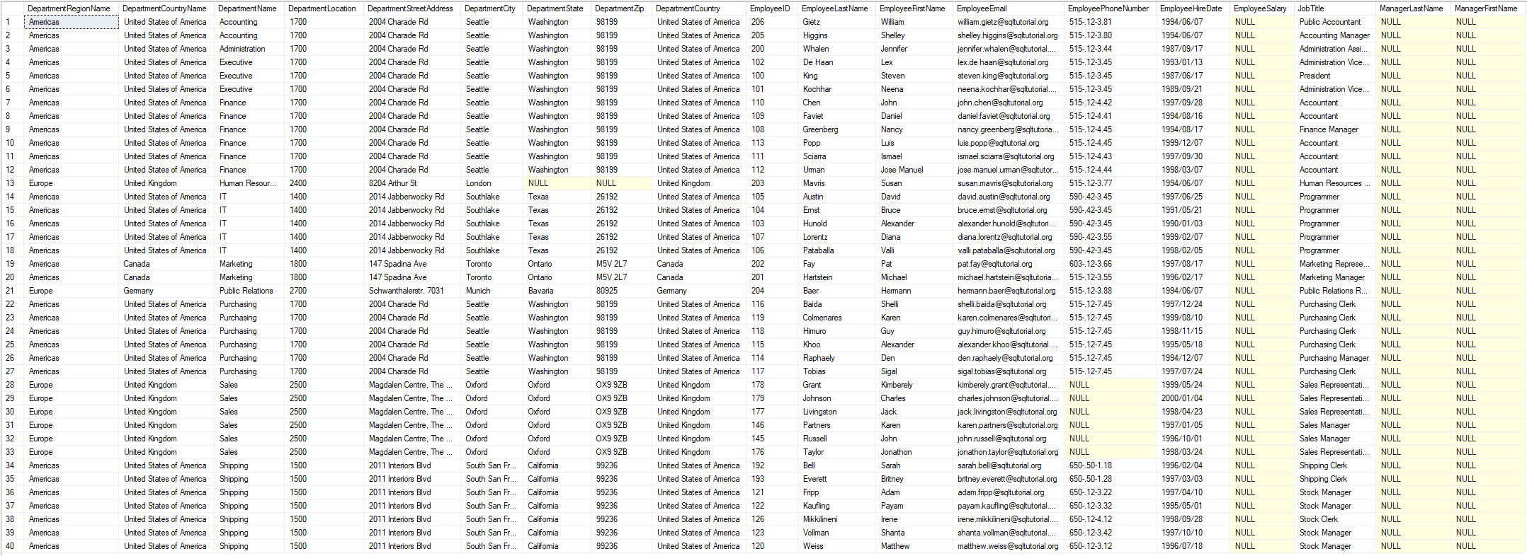

**Left Half of EmployeeDetails results:  
**

**Right half of EmployeeDetails results:  
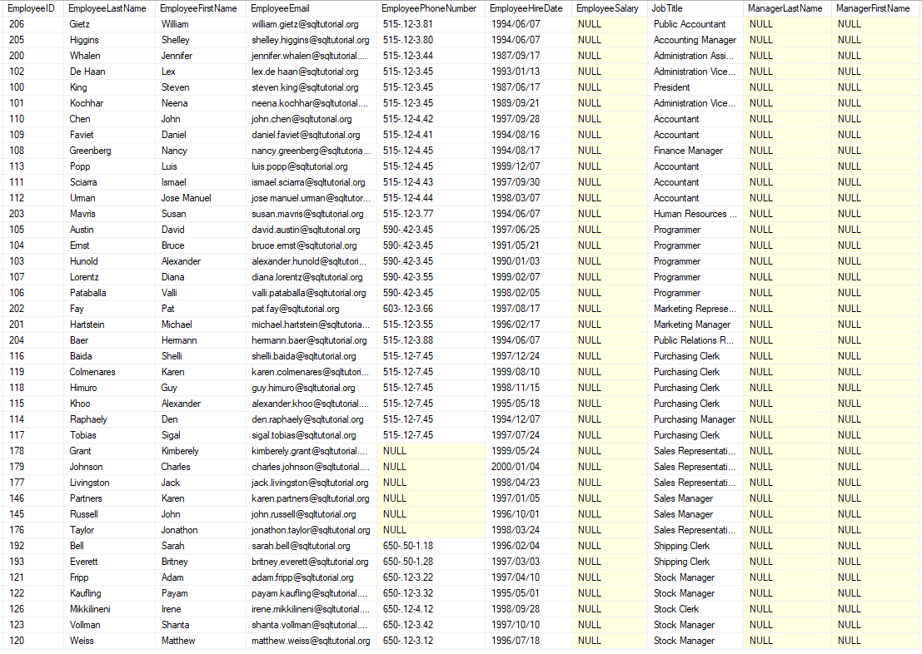**

# Scenario 3

Scenario Description: This scenario is intended to demonstrate that the database stats file, and the sql instructions therein, work

Scenario Screen Capture of Output:

